

**Internet and Web Programming**

**CSE3020**

**Food Park**

***From our casa to yours***

**By: Karen Pinto**

**Slot: B2**

**L21+L22**

**Submitted To: Lydia Jane**

**GitHub Link:** [**https://github.com/karenpinto1602/FoodPark-React**](https://github.com/karenpinto1602/FoodPark-React)

**Login:**

**Every VITian (Just Like Vtop) must Login.**

**With Registration Number and Password**

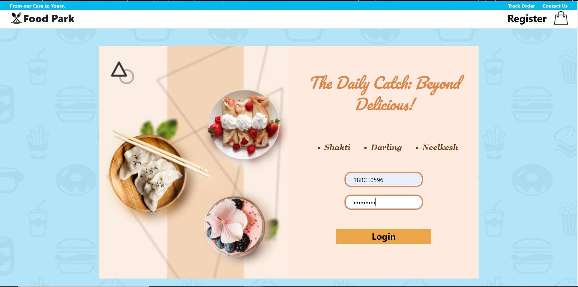

**Home:**

* **Every User will have access to the Mess Menu’s of all the 3 Kitchen.**
* **Every User will have access to the FoodPark Menu of all the 3 Kitchen.**

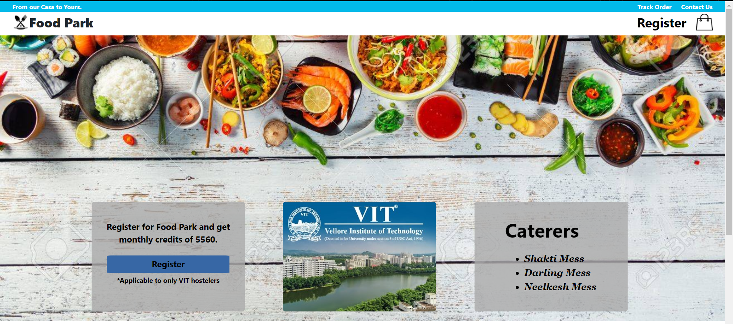

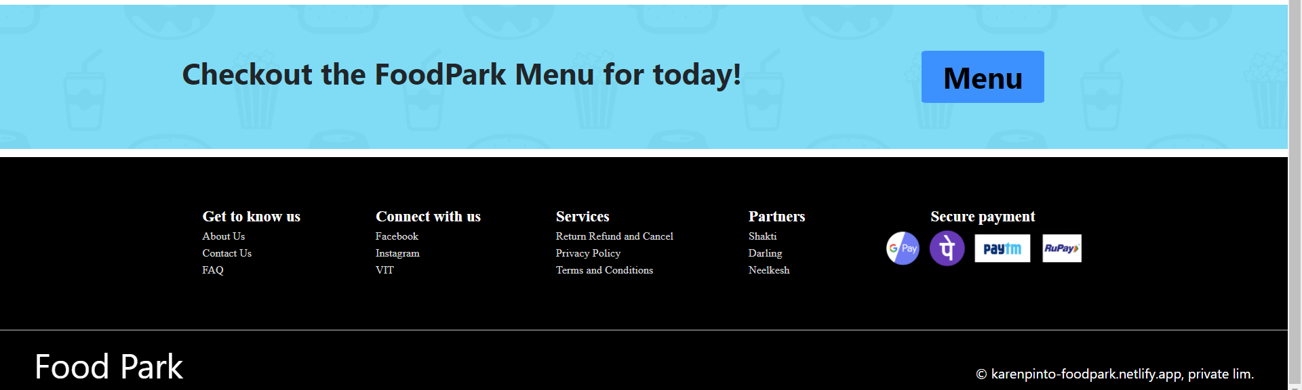

**Every Non-FoodPark Member can either view the normal Mess Menu**

**OR**

**Checkout the Food Court and Order Items for which they will have to pay by money.**

**OR**

**Register for FOODPARK and switch from normal MESS to FoodPark and order Items as per their wish through credits allotted to them monthly.**

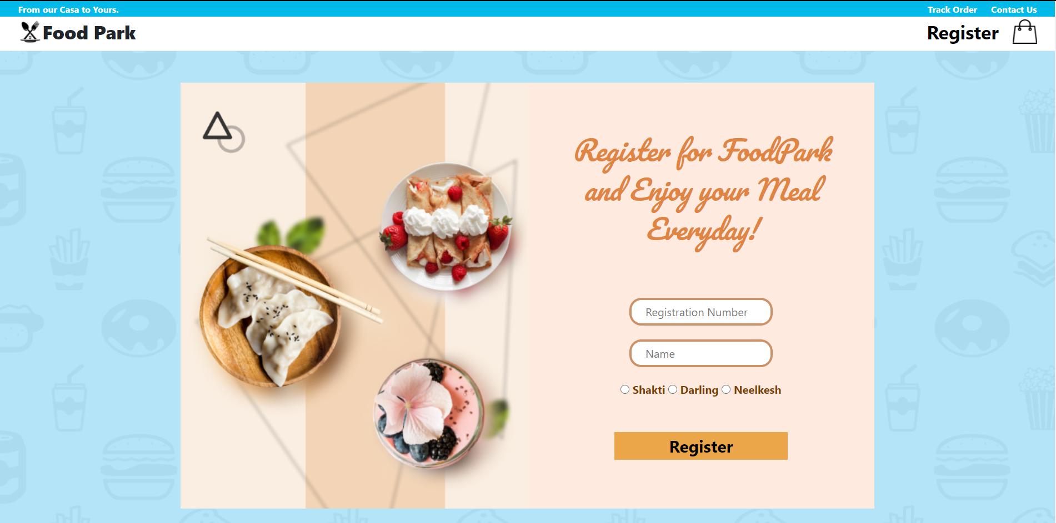

**(Students must choose any one Kitchen only)**

**Menu:**

* **3 Kitchens**
* **4 Meals**

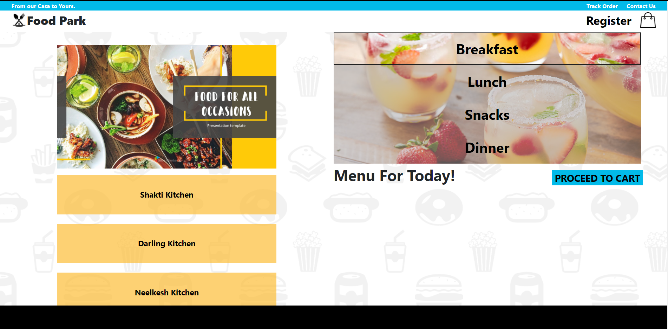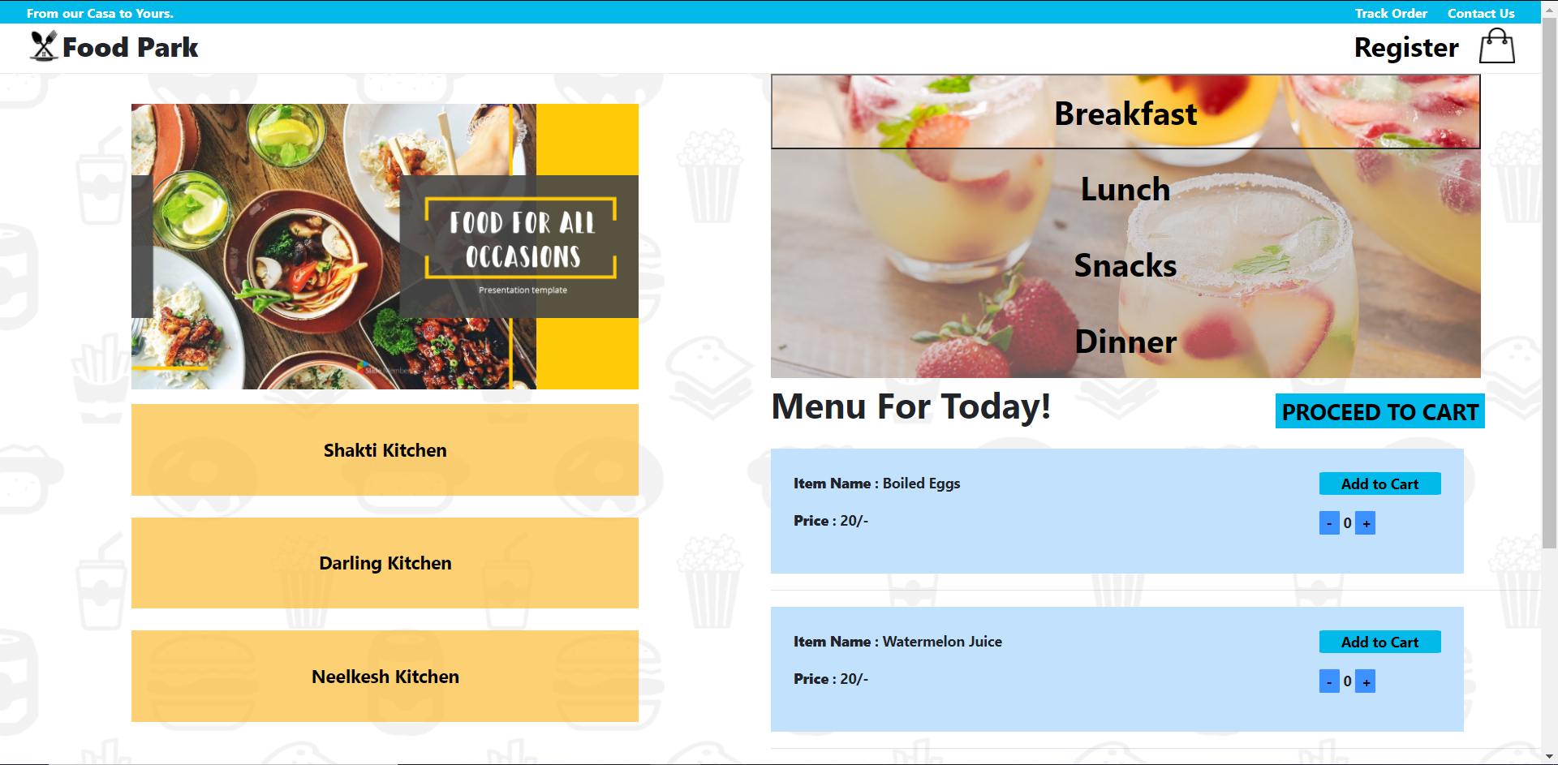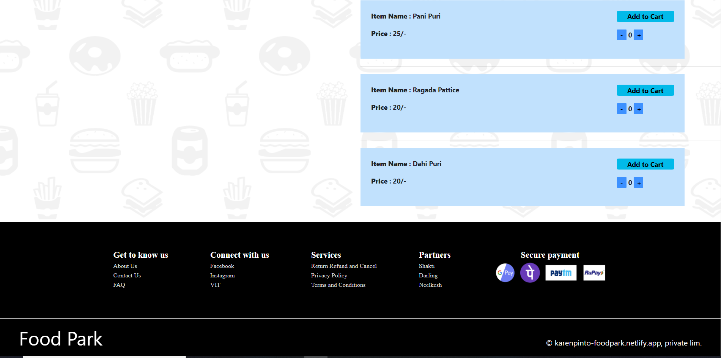

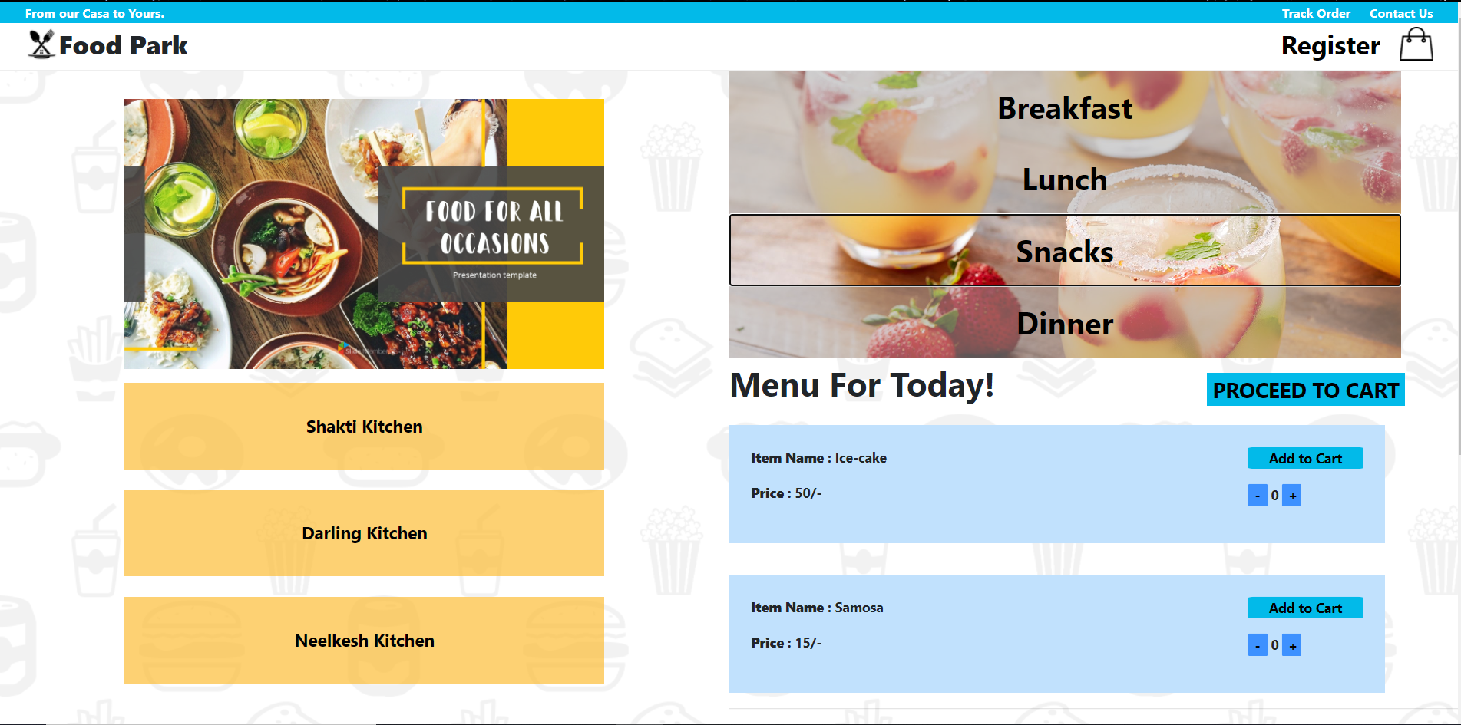

**Items will change based on the Kitchen button clicked and Filter Meal Clicked.**

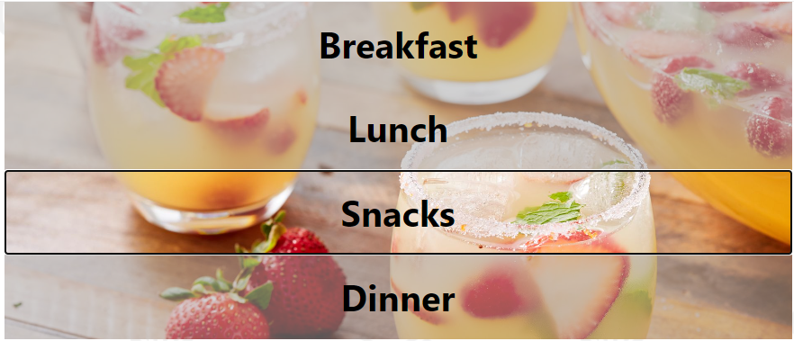

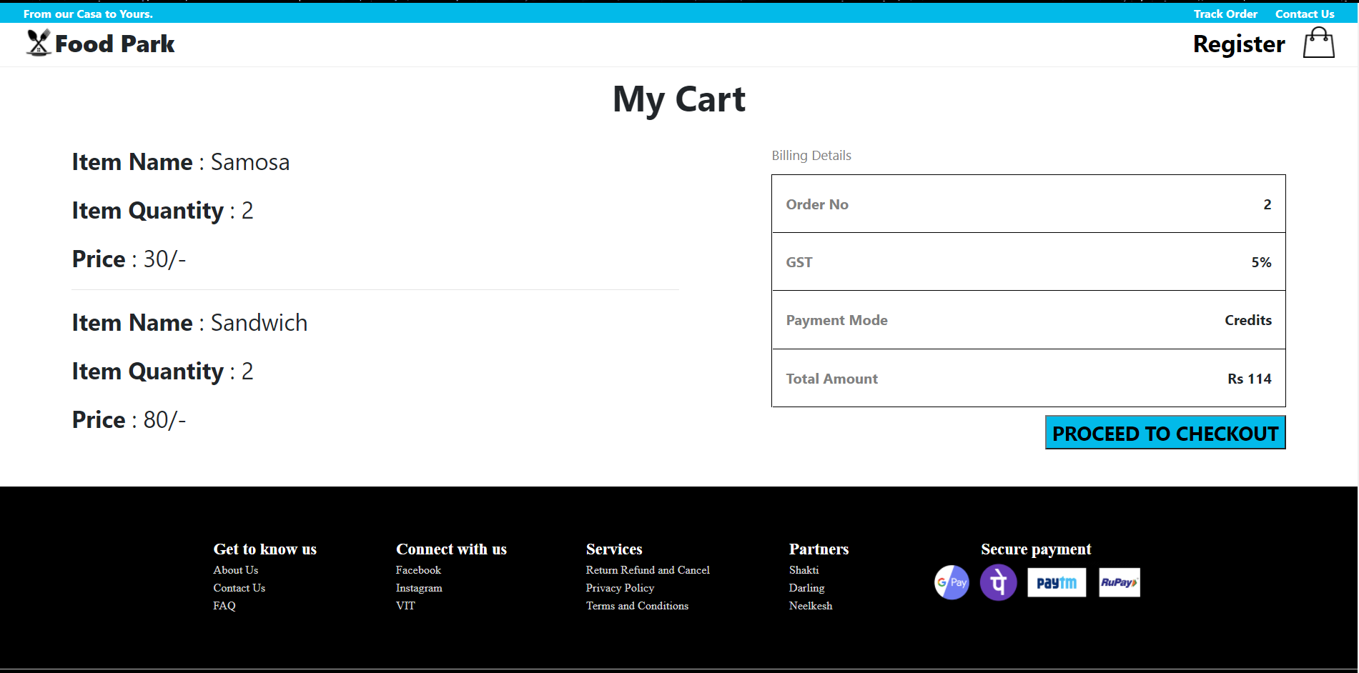

**Tables of the Database: (Stored in MongoDB and localhost:4001)**

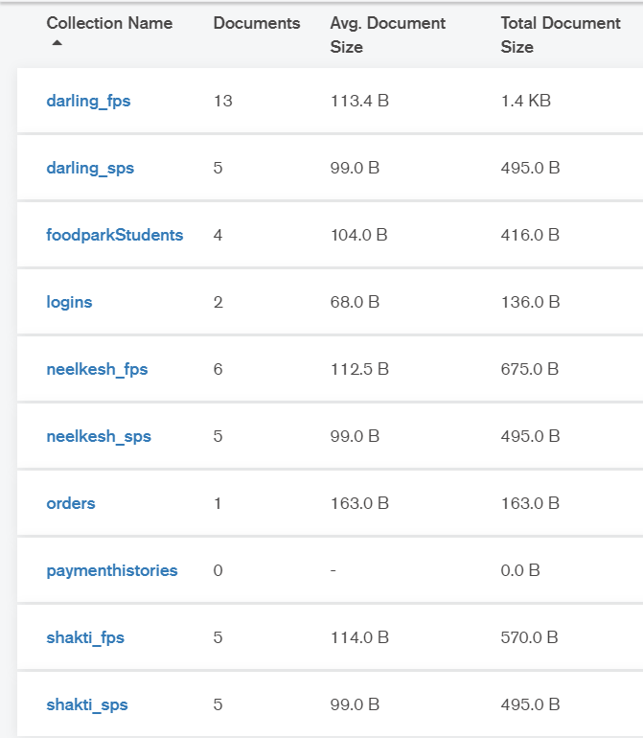

**Login:**

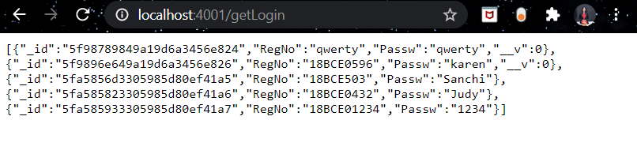

**FoodPark Students:**

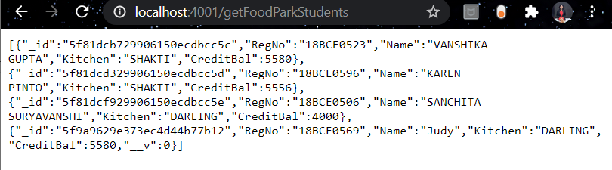

**Daring FoodPark Menu:**

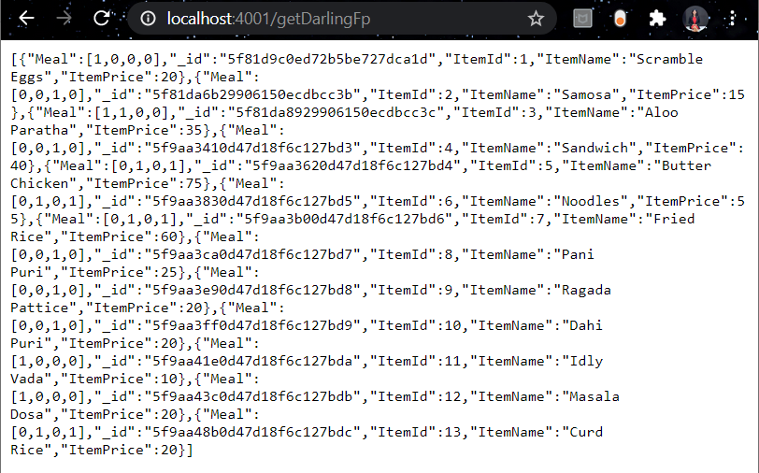

**The Menu above has items from all the four meals:**

**They are differed based on an array.**

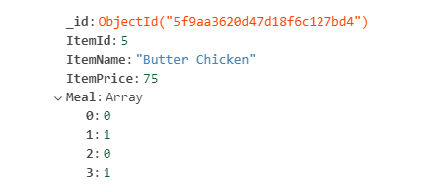

**Here, [0: False , 1: True]**

**0 -> Breakfast**

**1 -> Lunch**

**2 -> Snacks**

**3 -> Dinner**

**Therefore, here Butter Chicken can be in both Lunch and Dinner.**

**In my Project:**

* **I used Node JS and Mongo DB**
* **All the data was stored in localhost:4001**
* **To get and post the data from the locahost, *Axios Library* was used.**
* **To route between the pages, I used Routers.**
* **The backend is stored under the Server folder in the Project folder.**

**Server:**

**Database:**

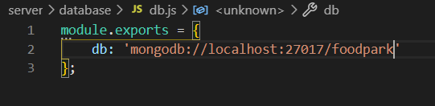

**I used mongoose to connect to the database.**

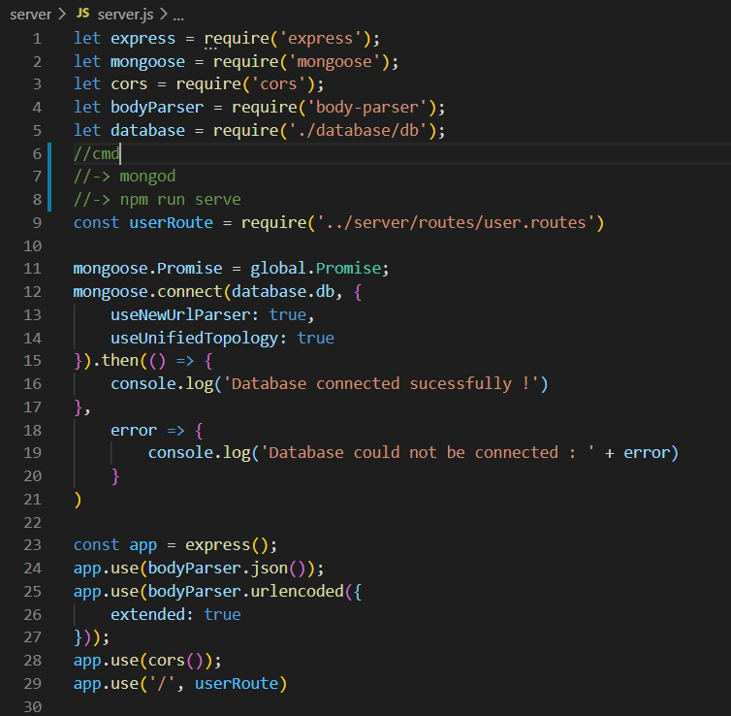

**All the Schemas are declared in the models folder under Server:**

**Eg: Darling FoodPark Menu Schema**

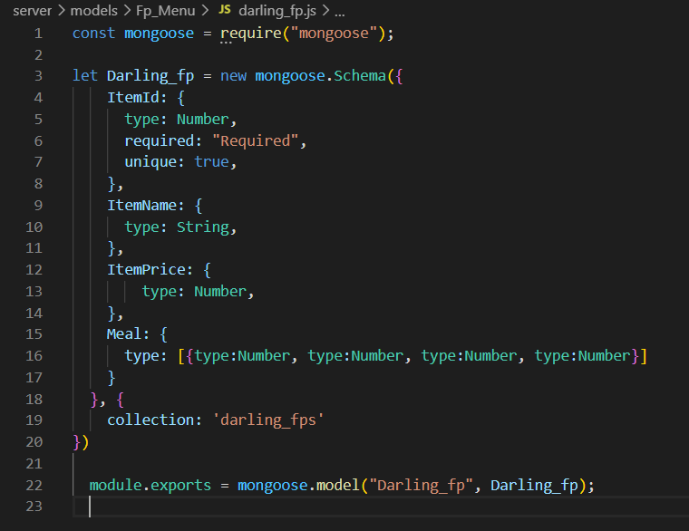

**Login Schema:**

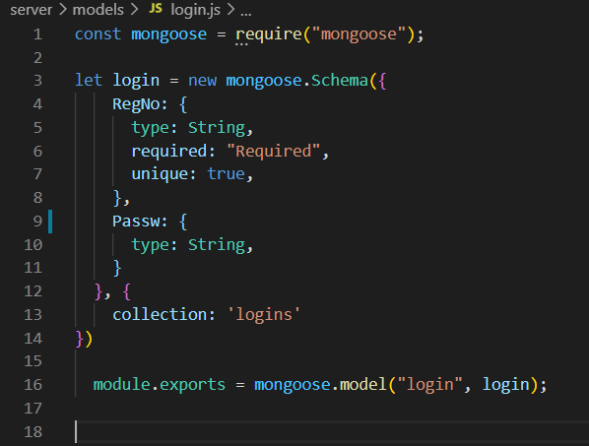

**Route:**

**To access data from the localhost:**

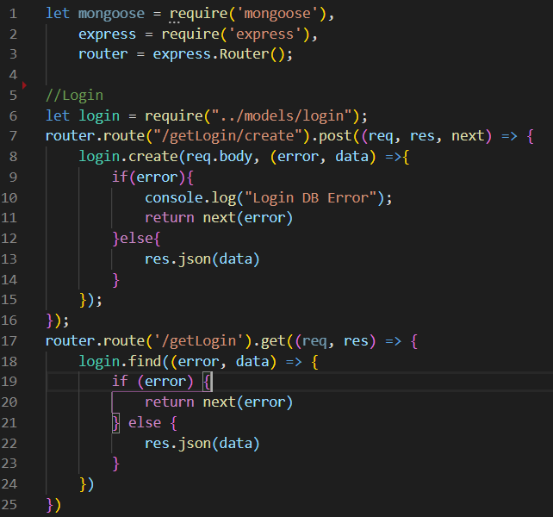

**The same is done for all the Models.**

**Finally, the Frontend: App.js**

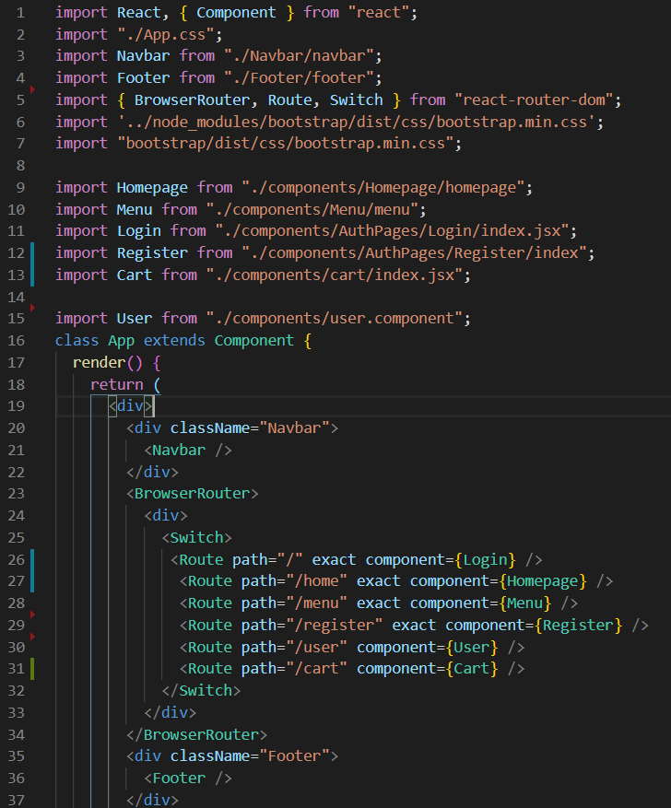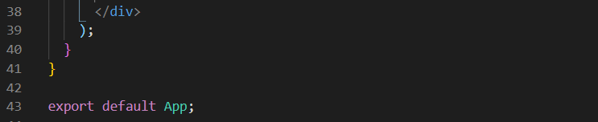

**Thank You**

**GitHub Link:** [**https://github.com/karenpinto1602/FoodPark-React**](https://github.com/karenpinto1602/FoodPark-React)

**When you run the code, you have to install node modules in both Server folder and Main Project folder.**